

Programming for Robotics: Project Report

Project Title: Maze Navigation Robot
GitHub link: https://github.com/cherry4049/OL4

Group number: OL4
Group Members: Jenjira Kongpong, s5393441
Xinghan TAi, s5251658
Yuehui Chen, s5361257

Course code & name: 3003ICT Programming for Robotics
Due Date: Mon 19 April, 2026 9:00
Specialisation Option Chosen:
☐ Embedded System (Wokwi)
☑ Autonomous Robot (Webots)
☐ Multi-Agent System (Webots)
☐ Human–Robot Interaction (Webots)

1. Project Overview
The goal of this project is to develop an autonomous robot using the Webots simulation platform capable of navigating a maze environment using sensor-based decision making. The robot operates independently, detects obstacles, and attempts to reach a predefined goal without human intervention.
The main problem addressed in this project is autonomous navigation in an unknown environment while avoiding collisions with walls or obstacles. This capability is important in real-world robotics applications such as exploration, search and rescue, and automated navigation systems.
The system is implemented as an autonomous robot simulated in the Webots robotics platform. The robot operates in a maze environment consisting of corridors, walls, and turns that require continuous navigation decisions based on sensor input.
Robot Purpose
The robot is designed to autonomously navigate through a maze while avoiding obstacles and locating a goal position.
Its core capabilities include wall detection, path adjustment, obstacle avoidance, and goal reaching using real-time sensor feedback.
Sensors Used
The robot uses multiple distance sensors and a forward-facing camera to perceive its environment. These sensors are grouped into three main directional inputs:
- Front sensors to detect obstacles directly ahead
- Left sensors to measure distance from the left wall
- Right sensors to measure distance from the right wall
- Camera to detect a coloured goal marker based on pixel colour information
These sensor readings allow the robot to determine whether the path is clear and to adjust its movement accordingly.
A forward-facing camera is used to detect a coloured goal marker (green wall). The robot identifies the goal based on visual input, enabling perception-based goal detection rather than relying on predefined position data.
Actuators Used
The robot uses two wheel motors to control its movement through a differential drive system.
By adjusting the speed of each wheel independently, the robot can:
- Move forward
- Turn left
- Turn right
- Make slight directional adjustments
- Stop
This enables precise navigation and smooth movement within the maze.
Intelligent Behaviour Implemented
The robot’s behaviour is controlled using a Finite State Machine (FSM), where each state represents a specific navigation behaviour and transitions are triggered by real-time sensor inputs.
During development, an initial right-hand wall-following strategy was implemented. However, this approach proved to be unstable in certain maze configurations, leading to issues such as looping and inconsistent navigation. To address this, the system was refined to use a sensor-difference-based control method, where the robot continuously adjusts its movement based on the difference between left and right distance sensor readings. This allows the robot to maintain a balanced position between walls and navigate more smoothly.
The final FSM consists of five states:
- Explore – the robot moves forward when no walls are nearby
- Wall Follow – the robot adjusts its direction based on sensor differences to navigate between walls
- Avoid – the robot turns to avoid obstacles detected in front
- Recovery (Fail-safe) – the robot performs corrective actions when it becomes stuck or fails to make progress
- Goal Reached – the robot stops when it reaches the goal location
Transitions between these states are triggered by sensor conditions such as obstacle detection, wall proximity, and goal position.
This approach enables adaptive, perception-driven navigation without requiring a global map of the environment. Compared to the initial right-hand rule approach, the improved method provides more stable and reliable behaviour, although it may still exhibit minor oscillations due to continuous correction.

2. Technical Requirements Compliance
The system satisfies all core technical requirements as follows:
- At least 2 inputs: The robot uses multiple distance sensors and a camera as input devices to detect obstacles and identify the goal.
- At least 2 outputs: Two wheel motors are used to control movement, enabling forward motion, turning, and stopping.
- FSM / Behaviour Model: A Finite State Machine (FSM) is implemented to manage robot behaviour.
- Minimum 4 behavioural states: The system includes five states: Explore, Wall Follow, Avoid, Recovery, and Goal Reached.
- Multi-condition decision logic: Decisions are based on multiple sensor conditions, such as front obstacle detection and left–right distance differences.
- Safety / fail-safe mechanism: A Recovery state is used to handle situations where the robot becomes stuck.
- Structured architecture: The system is modular, separating sensing, decision-making, and actuation.
The project satisfies the Autonomous Robotics (Webots) requirement by demonstrating navigation, obstacle avoidance, and perception-driven decision making.

3. System Architecture
The system follows a Sense → Process → Decide → Act architecture:
- Sense: Distance sensors and the camera collect real-time environmental and visual data.
- Process: Sensor values are grouped into front, left, and right distances.
- Decide: The FSM determines the current state and selects an action based on sensor inputs.
- Act: Motor commands are executed to move the robot accordingly.
Information flows continuously in a loop: sensor data is read, processed into meaningful values, used to update the FSM state, and translated into motor actions.

4. Behaviour Model
The robot uses a Finite State Machine (FSM) to control behaviour.
States:
- Explore: Robot moves forward when no walls are nearby
- Wall Follow: Robot adjusts direction using the difference between left and right sensor values
- Avoid: Robot turns when an obstacle is detected in front
- Recovery: Robot performs corrective turning when stuck
- Goal Reached: Robot stops when it reaches the goal
State Transitions:
- Explore → Wall Follow: when walls are detected
- Any state → Avoid: when front obstacle is detected
- Avoid → Explore: after obstacle is cleared
- Any state → Recovery: when no progress is detected
- Any state → Goal Reached: when goal position is reached
Justification:
The FSM model was chosen because it provides a clear and structured way to manage multiple behaviours. It allows the robot to react dynamically to sensor inputs while maintaining organised control logic.

5. Perception / Sensor Processing
The robot uses distance sensors as its primary perception system.
Data Processing:
- Raw sensor values are read from multiple infrared proximity sensors on the E-puck robot.
- Sensor readings are grouped into directional signals:
  - Front distance: detects obstacles directly ahead
  - Left distance: detects obstacles on the left side
  - Right distance: detects obstacles on the right side
Decision Logic:
- Camera data is processed using simple colour-based classification, enabling the robot to detect the goal visually in addition to distance-based navigation.
- Front sensor priority:
If the front distance exceeds a defined threshold, the robot performs obstacle avoidance by turning away from the obstacle.
- Wall balancing:
A left–right difference is calculated:
diff = left − right
This value is used to keep the robot centred in corridors and prevent drifting toward walls.
- Threshold-based control:
Predefined threshold values determine when the robot should:
- Move forward
- Turn left
- Turn right
- Perform obstacle avoidance manoeuvres

Goal Detection:
The robot uses an onboard camera to detect a coloured goal marker (green wall). Image data is processed in real time by analysing pixel colour values. To improve robustness, a temporal confirmation mechanism is applied, requiring consistent detection over multiple time steps before transitioning to the “Goal Reached” state. This reduces false positives caused by distant or partially visible objects.

6. Safety and Robustness
The system includes several safety and robustness mechanisms:
- Collision avoidance: The robot detects obstacles using front sensors and enters the Avoid state to prevent collisions.
- Fail-safe (Recovery state): If the robot becomes stuck or stops making progress, it performs corrective turning actions.
- Continuous sensor monitoring: The robot constantly updates its decisions based on real-time data, allowing it to adapt to unexpected situations.
- Robust goal detection: Temporal filtering of camera input prevents premature goal detection when the goal is still far away.
If sensor readings become unstable or the robot encounters complex maze structures, the Recovery behaviour ensures it can escape and continue navigating.

7. Code Structure
The system is modular and organised into separate components:
- main_controller.py: Controls the main loop and integrates all modules
- fsm.py: Implements the Finite State Machine logic
- sensors.py: Handles sensor reading and data processing
- movement.py: Controls motor actions
- config.py: Stores thresholds and constants

Control Loop:
- Read sensor data
- Update FSM state
- Get action from FSM
- Execute movement
This structure improves readability, maintainability, and debugging.

8. Key Code Snippets
Example: FSM Wall Follow Logic
if self.state == "WALL_FOLLOW":
diff = left - right

if diff > WALL_DIFF_STRONG:
return "TURN_RIGHT"
elif diff < -WALL_DIFF_STRONG:
return "TURN_LEFT"
elif diff > WALL_DIFF_SMALL:
return "SLIGHT_RIGHT"
elif diff < -WALL_DIFF_SMALL:
return "SLIGHT_LEFT"
else:
return "MOVE_FORWARD"
This logic allows the robot to continuously adjust its direction and maintain balance between walls.

Example: Sensor Processing
front = (values[7] + values[0]) * 0.5
left = values[6]
right = values[1]

Raw sensor values are mapped to directional inputs (front, left, right). The front distance is calculated as the average of two forward-facing sensors, while the left and right distances are taken directly from side sensors.

9. Results / Demonstration Summary
The robot successfully demonstrates:
- Autonomous navigation through a maze
- Obstacle detection and avoidance
- Continuous path adjustment using sensor feedback
- Goal detection and stopping behaviour
The robot is able to reach the goal without human intervention, typically within approximately two minutes.

Limitations:
- The robot exhibits minor oscillation (zig-zag movement) due to continuous correction
- The navigation strategy does not guarantee the shortest path
- Performance may vary depending on maze complexity
Despite these limitations, the system demonstrates reliable and adaptive behaviour using real-time sensor data.

10. Individual Contributions

Tasks breakdown (example: Maze Navigation Robot)
Member | Main Responsibilities
A – Yuehui Chen | Project planning, FSM / behaviour logic design, system architecture, report drafting, integrating modules, GitHub coordination, video coordination
B – Jenjira Kongpong | Robot movement & navigation implementation, maze setup, integrate movement with FSM
C – Xinghan Tai | Sensor integration and processing, obstacle/exit detection, testing and debugging
All Members | Integration, final testing, recording the demonstration video (everyone speaks), final checks before submission

Timeline schedule (example: Maze Navigation Robot)
Week | Tasks | Member A (Leader) | Member B | Member C
Week 3 | Planning & Early Design | - Draft FSM states and transitions;  - Start system architecture diagram | - Draft movement function placeholders (move_forward(), turn_left()) | - Draft sensor reading logic;  - Plan distance sensor thresholds
Week 4 | Planning & Code Structure | - Refine FSM diagram;  - Define multi-condition decision logic | - Define movement control functions in detail | - Define sensor data processing functions;  - Map input → state transitions
Week 5 | Webots Setup | - Map FSM design to Webots robot;  - Review Webots tutorials | - Import robot & maze environment;  - Configure wheel motors | - Configure distance sensors (front/left/right) in Webots;  - Test basic readings
Week 6 | FSM Implementation & Navigation | - Implement FSM structure in Webots; i  - Integrate with placeholder sensor logic | - Implement basic movement functions in Webots;  - Test moving forward, turning | - Feed sensor values to FSM;  - Debug simple state transitions
Week 7 | Maze Navigation Logic | - Refine FSM transitions for wall-following | - Implement wall-following logic;  - Itegrate with FSM | - Test sensor detection for walls;  - Adjust thresholds for turns
Week 8 | Sensor Processing & Multi-Condition Logic | - Review FSM transitions for corner cases | - Integrate sensor outputs to movement decisions | - Implement exit detection;  - Verify multi-condition triggers for FSM
Week 9 | Obstacle Avoidance & Safety Mechanisms | - Update FSM to include emergency stop / fail-safe | - Implement obstacle avoidance in movement functions | - Adjust sensor thresholds; test fail-safe responses;  - Debug stuck robot scenarios
Week 10 | Integration & Testing | - Integrate all FSM, movement, and sensor modules | - Run full maze tests;  - Debug navigation | - Run sensor checks;  - Verify state transitions;  - Refine thresholds
Week 11  (Mon–Fri) | Finalizing Project | - Finalize report sections;  - Clean up GitHub repo;  - Coordinate video recording | - Ensure robot performs correctly in maze;  - Participate in video demo | - Ensure sensor data works consistently;  - Test final robot runs;  - Participate in video demo;
Week 12 | Class Demonstration / Q&A | - Present robot behaviour in class;  - Answer questions | - Present navigation & movement logic  - Answer questions | - Present sensor processing & results  - Answer questions

Reference List

Appendix A: Architecture Diagram

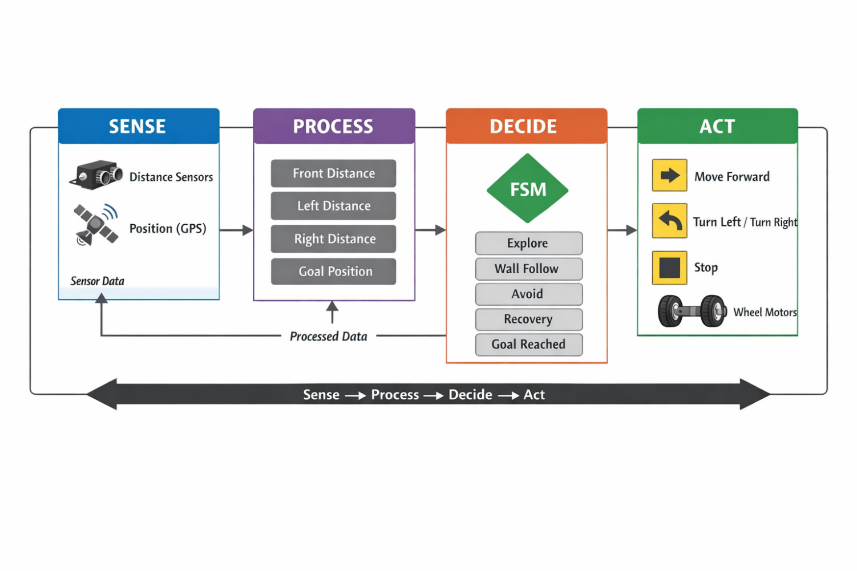
Figure 1 Architecture Diagram for Maze Navigation

The robot’s behaviour is controlled using a Finite State Machine (FSM), where each state represents a specific navigation behaviour and transitions are triggered by real-time sensor inputs.
The robot’s behaviour is controlled using a Finite State Machine (FSM), where each state represents a specific navigation behaviour and transitions are triggered by real-time sensor inputs.
During development, the initial right-hand rule strategy was found to be unstable in certain maze configurations. The system was refined to use a sensor-difference-based control method, resulting in smoother and more reliable navigation.
The improved FSM consists of five states: Explore, Wall Follow, Avoid, Goal Reached, and Recovery (Fail-safe).
- The robot begins in the Explore state, where it moves forward while scanning the environment using distance sensors.
- When nearby walls are detected, the robot transitions to the Wall Follow state. In this state, navigation is achieved using a sensor-difference control strategy, where the robot continuously adjusts its direction based on the difference between left and right sensor readings. This allows the robot to maintain a balanced position between walls and move smoothly through the maze.
- If an obstacle is detected directly in front of the robot, it transitions to the Avoid state. In this state, the robot performs a turning manoeuvre to prevent collisions and reorient itself.
- A Recovery (Fail-safe) state is implemented to handle situations where the robot becomes stuck or fails to make progress. This ensures robustness and improves system reliability under uncertain conditions.
- When the robot reaches the goal area (identified using position-based detection of the green goal wall), it transitions to the Goal Reached state and stops all movement.
This FSM enables adaptive, perception-driven navigation without requiring a predefined map. Compared to the initial right-hand wall-following approach, this improved design uses continuous sensor feedback to produce smoother and more stable behaviour, reducing the likelihood of looping and improving overall navigation performance.

